***Katarzyna Kosicka***

**My SQL**

**“World DataBase”**

Table of Contents

Task1# SQL Script “ World Data Base” imported. 3

Task2# “World Data Base” Executed 4

Task3# Actioned output 5

Task4# New Query Tab 5

Task5# Using ”count”, finding number of cities in USA. 6

Task6# Population in Argentina 6

Task7# Using” ORDER BY, LIMIT”, which country has the highest life expectancy? Limit 10 7

Task8# Select 25 cities around the world that start with the letter 'F' in a single SQL query. 8

Task9# Create a SQL statement to display columns Id, Name, Population from the city table and limit results to first 10 rows only. 9

Task10# City table whose population is larger than 2000000 9

Task11# All city names from city table whose name begins with “Be” prefix. 10

Task12# Cities from city table whose population is between 500000-1000000. 11

Task13# City with the lowest population in the city table. 11

Task14# Capital of Spain (ESP). 12

Task15# All the languages spoken in the Caribbean region. 12

Task16# All cities from the Europe continent. 13

Task17# EER Diagram- Reverse Engineer 13

Task18# Primary key in country table. 14

Task19# Primary key in city table 14

Task20# Primary key in countrylanguage table. 15

Task21# Foreign key in city table 15

Task22# Foreign key in countrylanguage table 16

Task23# Relation between tables. 16

# Task1# SQL Script “ World Data Base” imported.

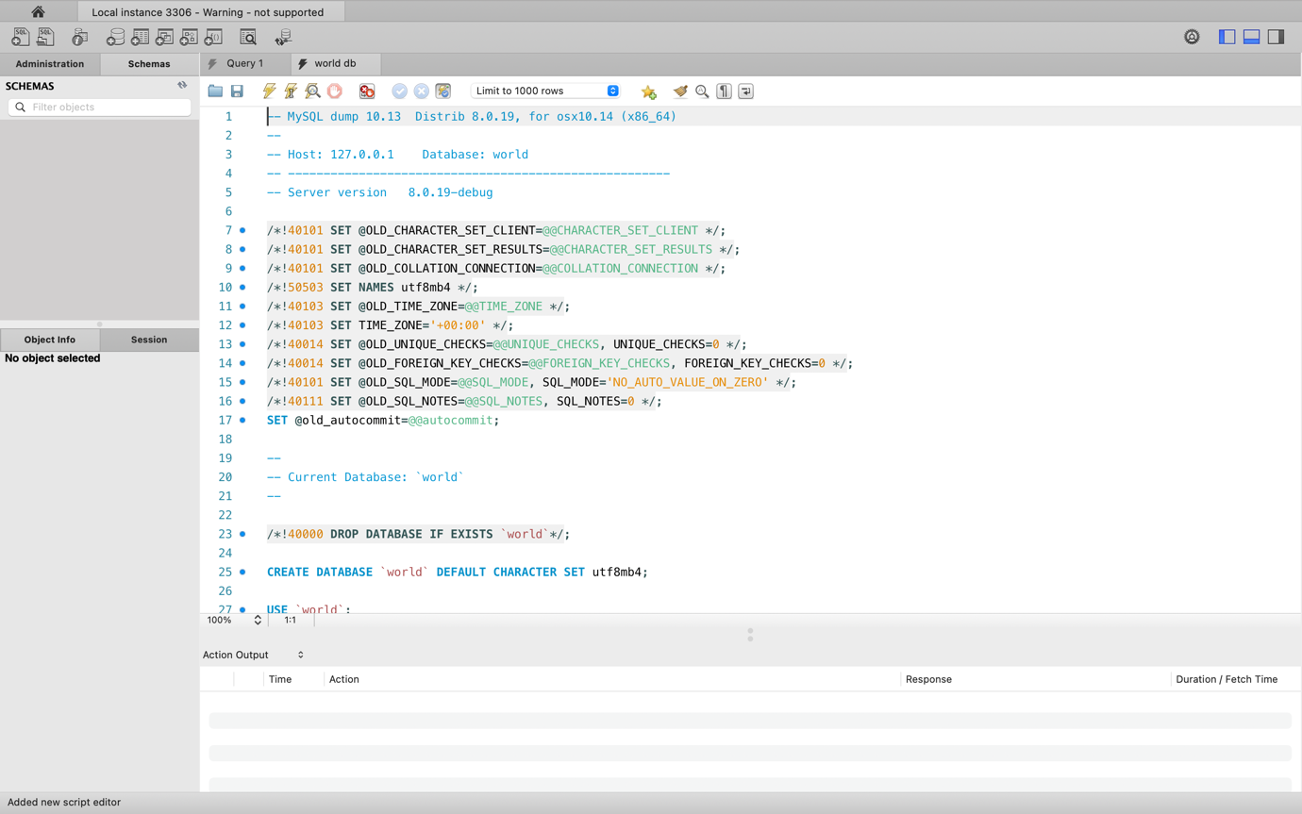

# Task2# “World Data Base” Executed

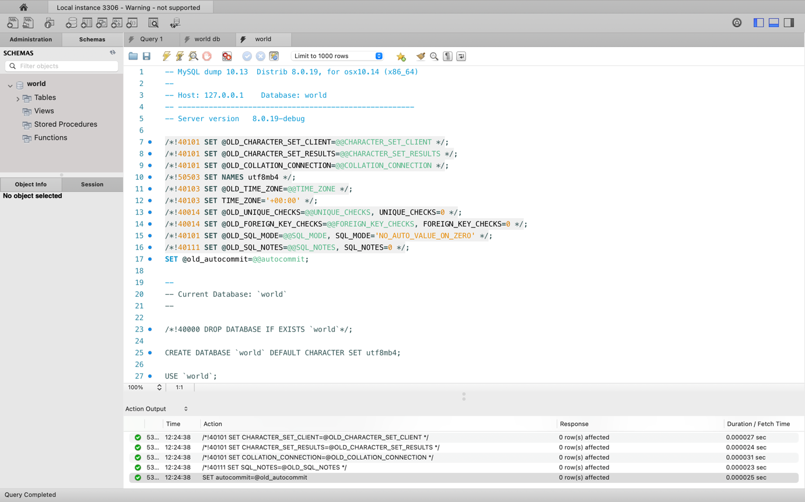

# Task3# Actioned output

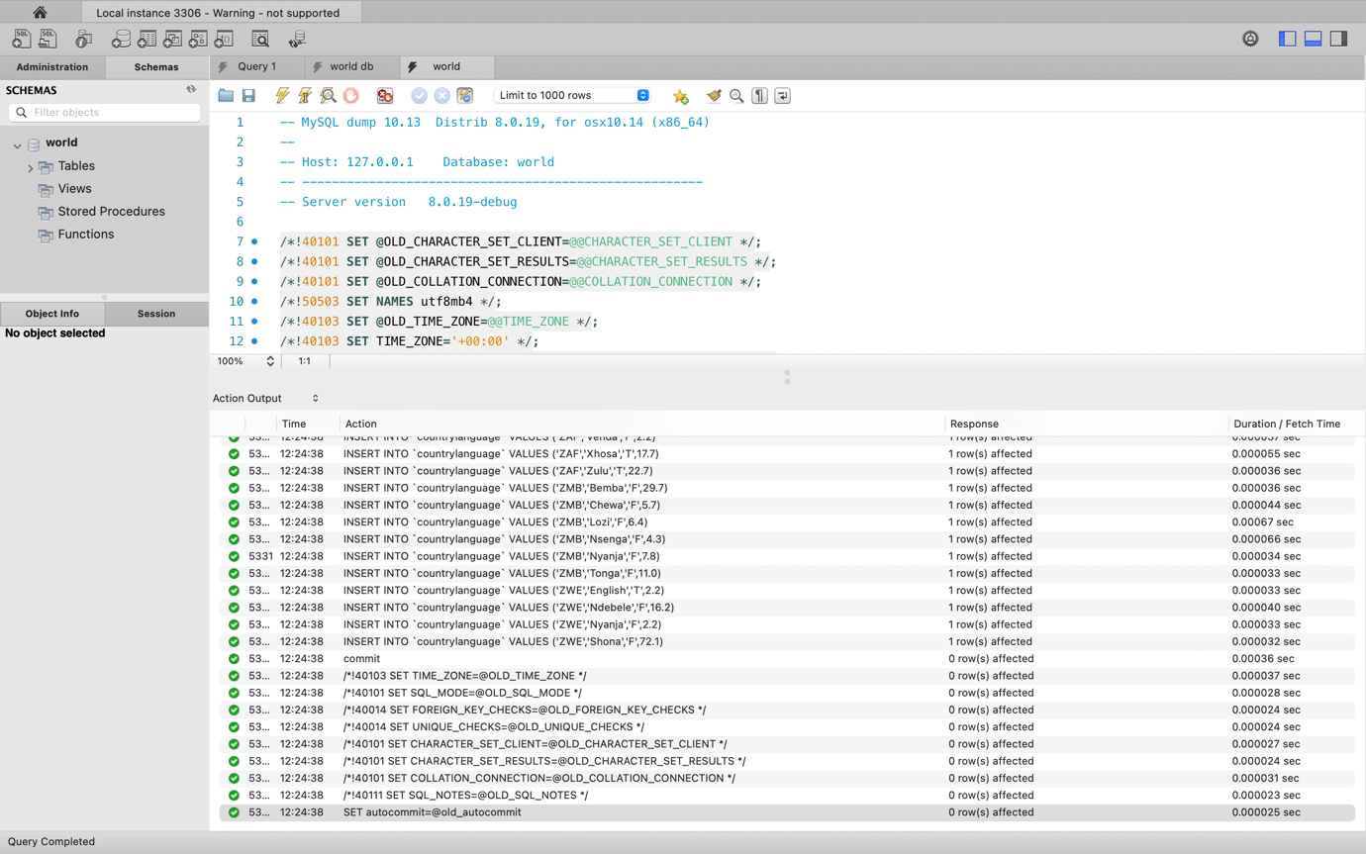

# Task4# New Query Tab

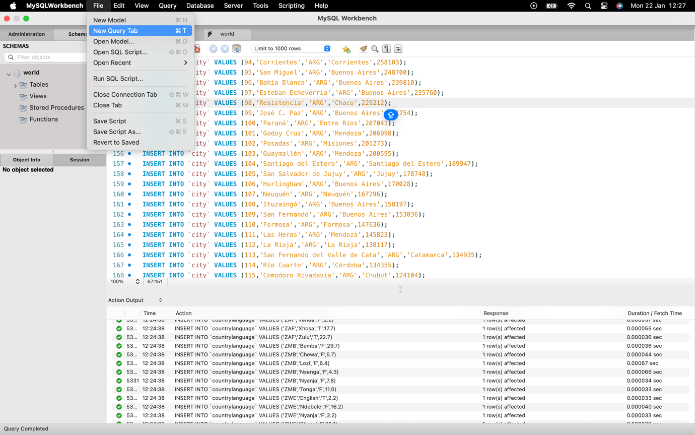

# Task5# Using ”count”, finding number of cities in USA.

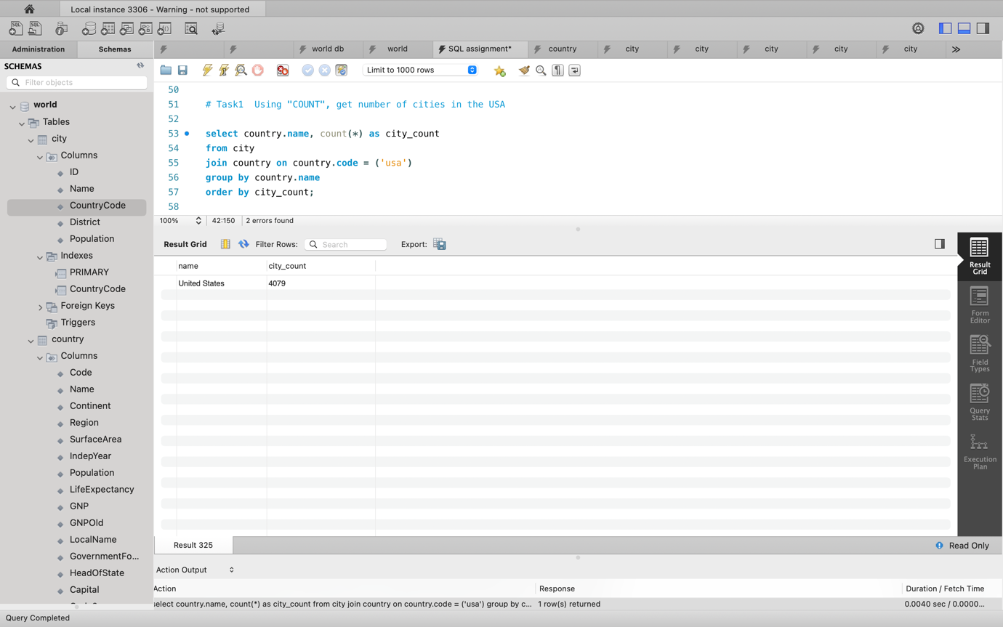

# Task6# Population in Argentina

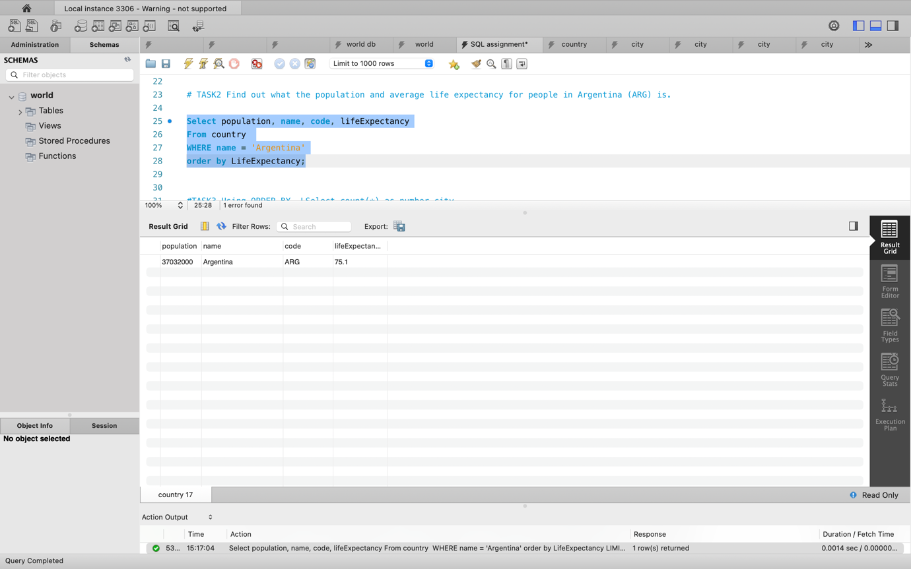

# Task7# Using” ORDER BY, LIMIT”, which country has the highest life expectancy? Limit 10

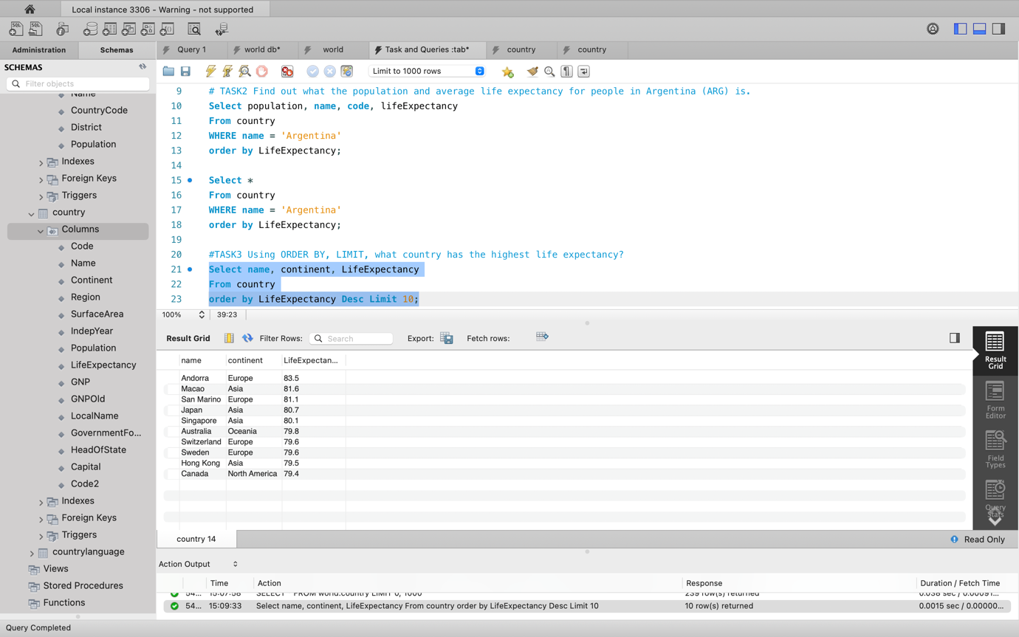

Using” ORDER BY, LIMIT”, which country has the highest life expectancy? Limit 20

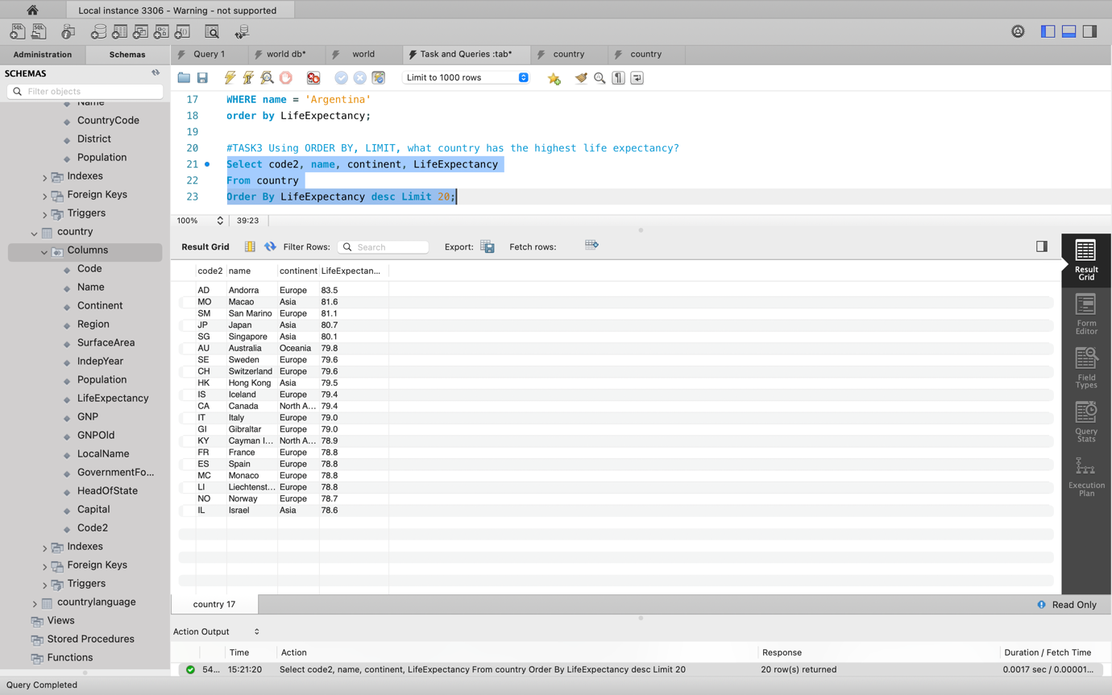

# Task8# Select 25 cities around the world that start with the letter 'F' in a single SQL query.

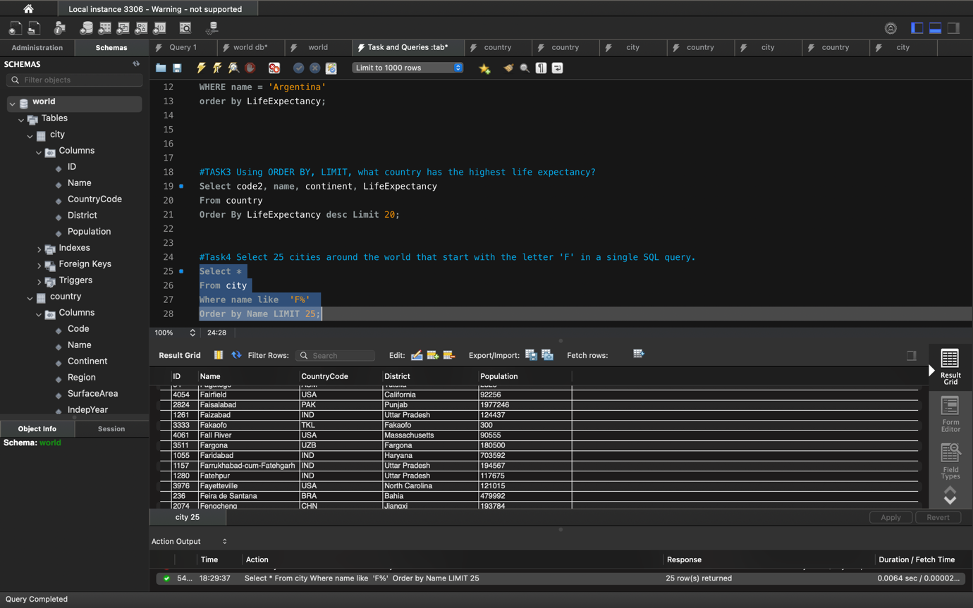

# Task9# Create a SQL statement to display columns Id, Name, Population from the city table and limit results to first 10 rows only.

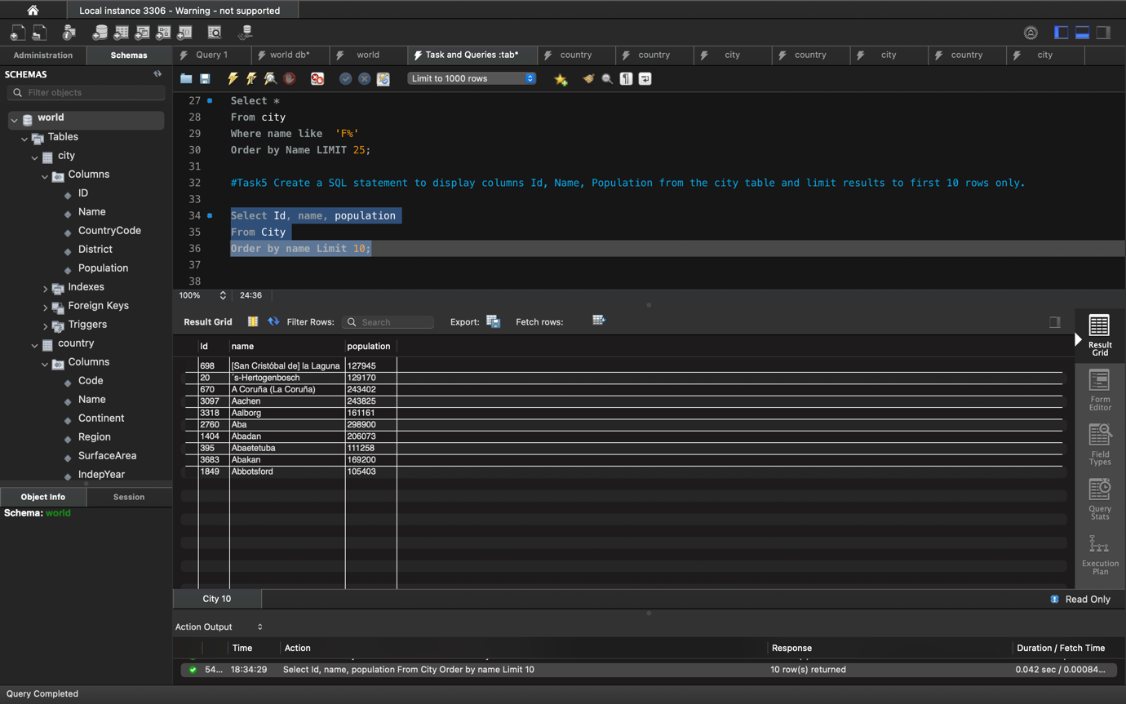

# Task10# City table whose population is larger than 2000000

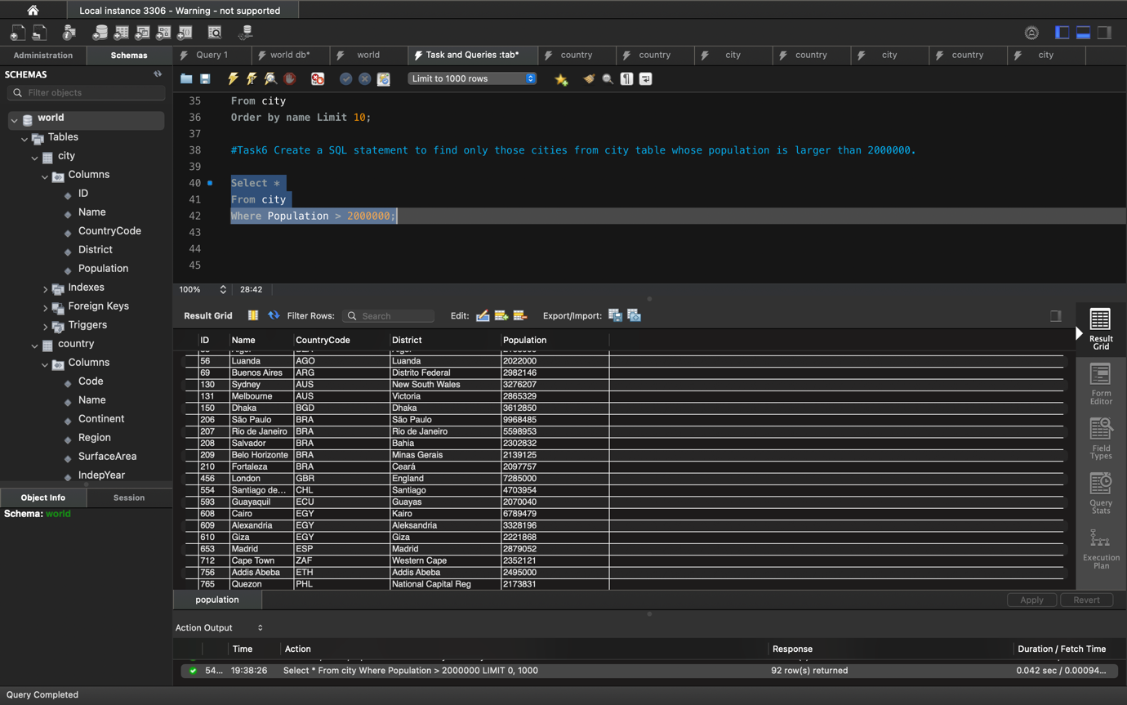

# Task11# All city names from city table whose name begins with “Be” prefix.

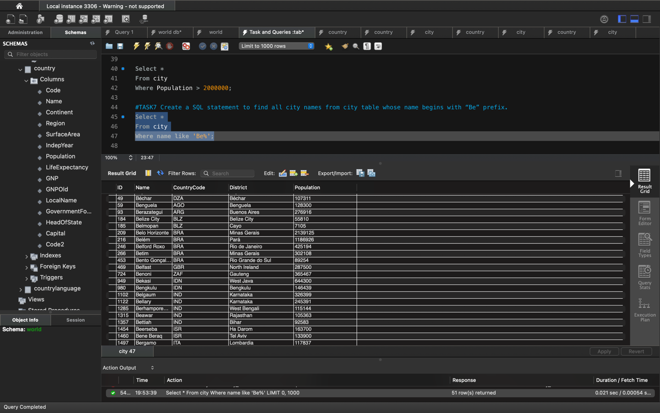

# Task12# Cities from city table whose population is between 500000-1000000.

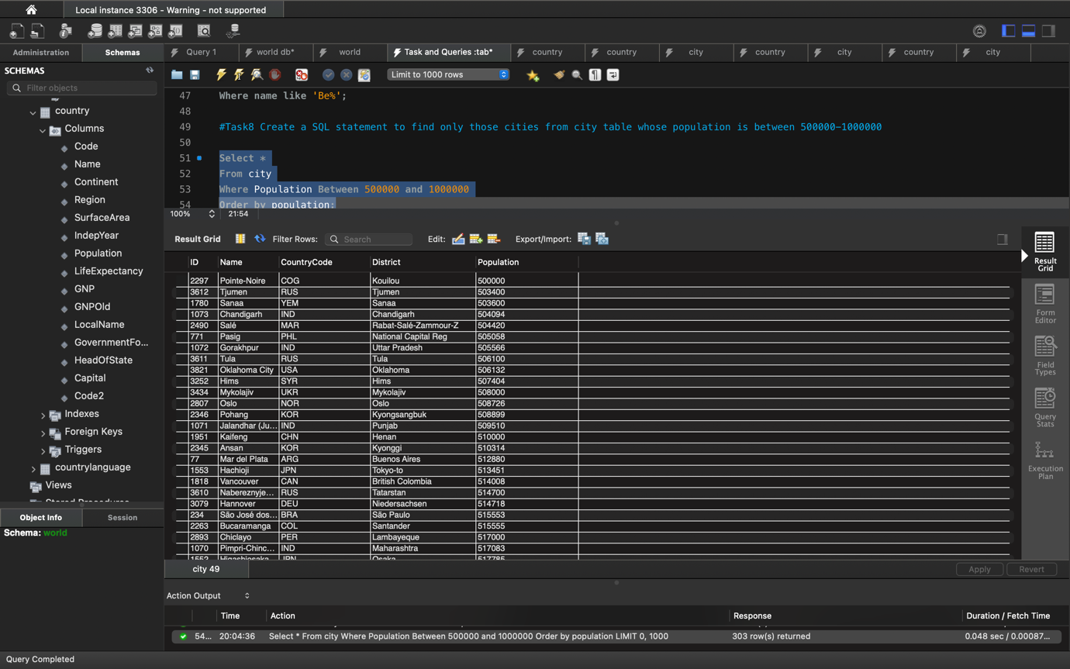

# Task13# City with the lowest population in the city table.

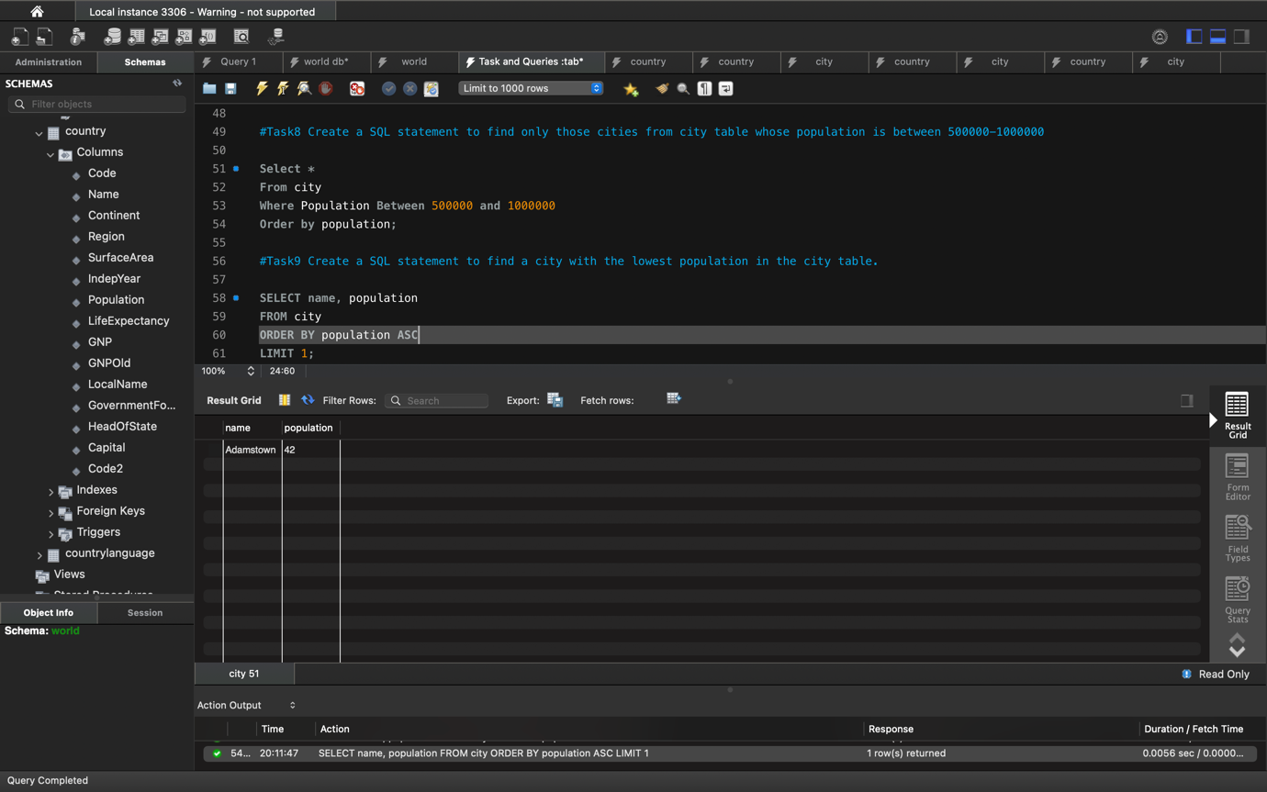

# Task14# Capital of Spain (ESP).

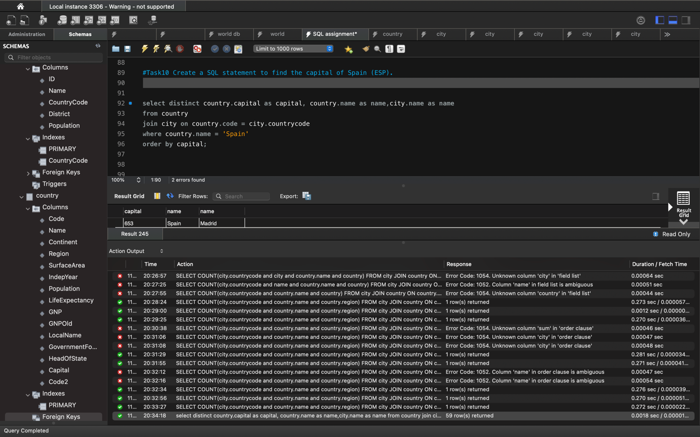

# Task15# All the languages spoken in the Caribbean region.

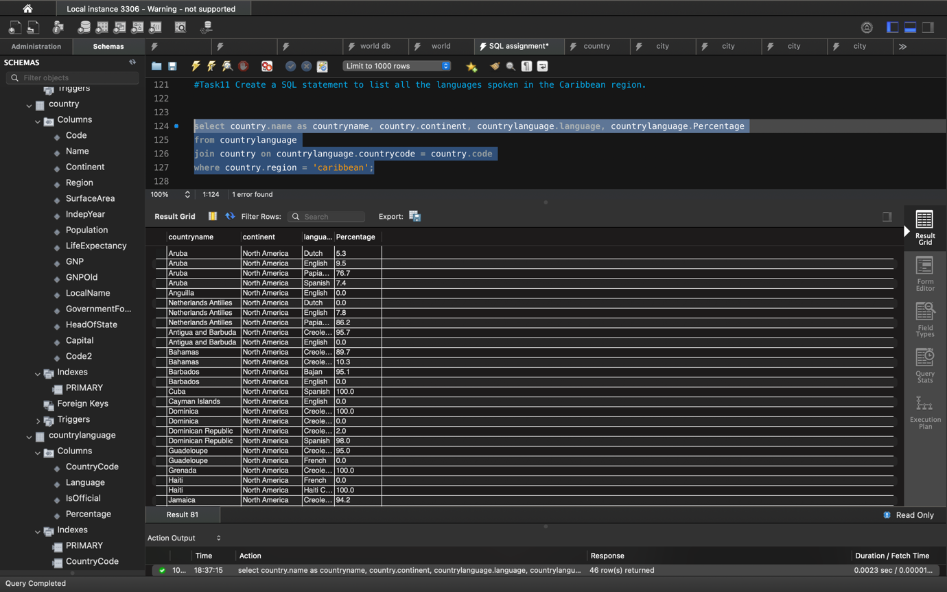

# Task16# All cities from the Europe continent.

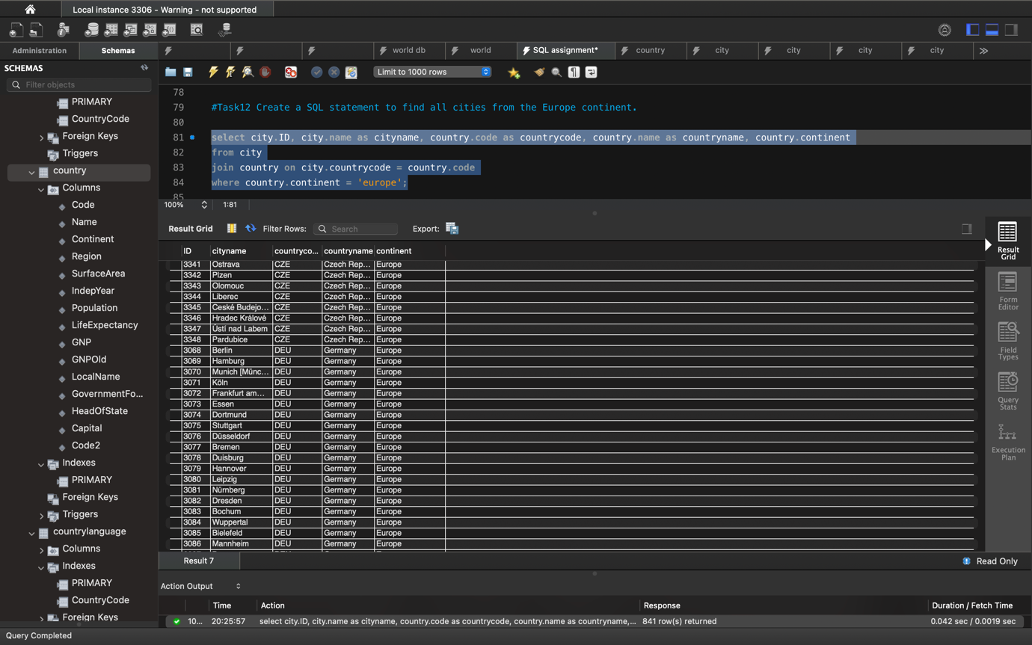

# Task17# EER Diagram- Reverse Engineer

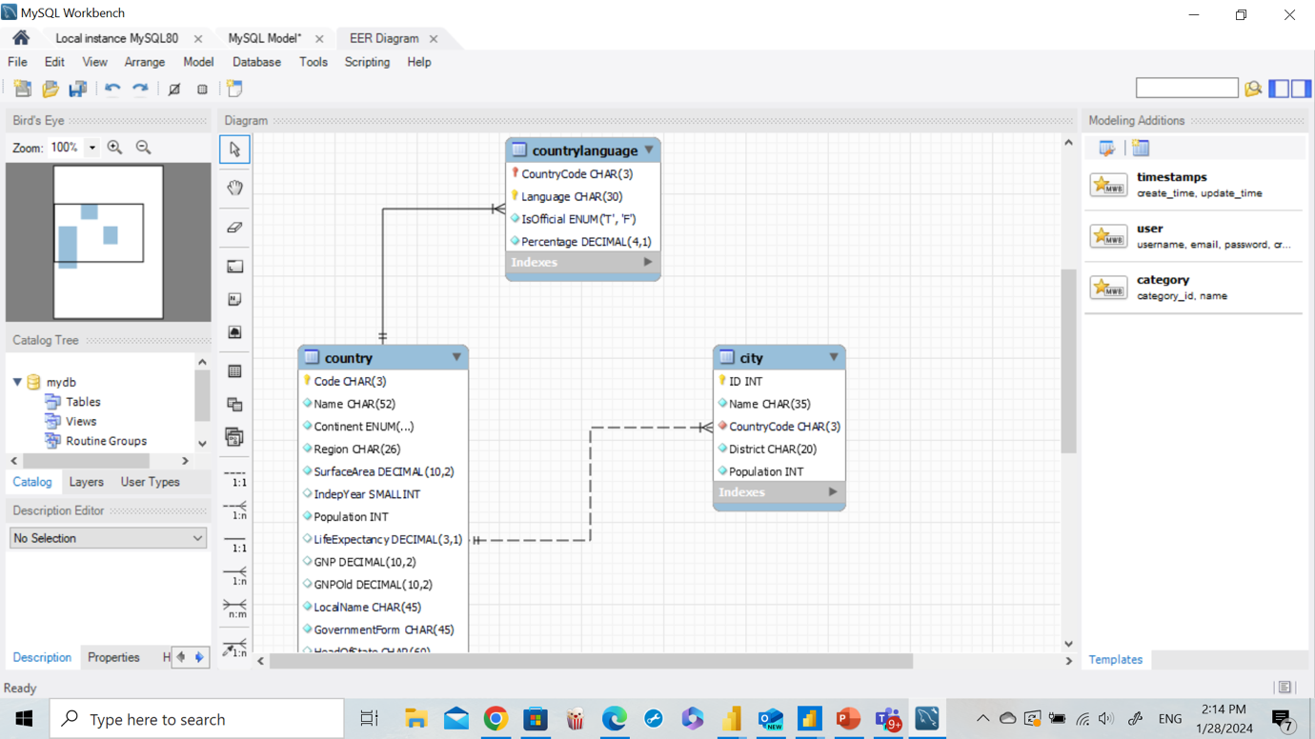

# 

# Task18# Primary key in country table.

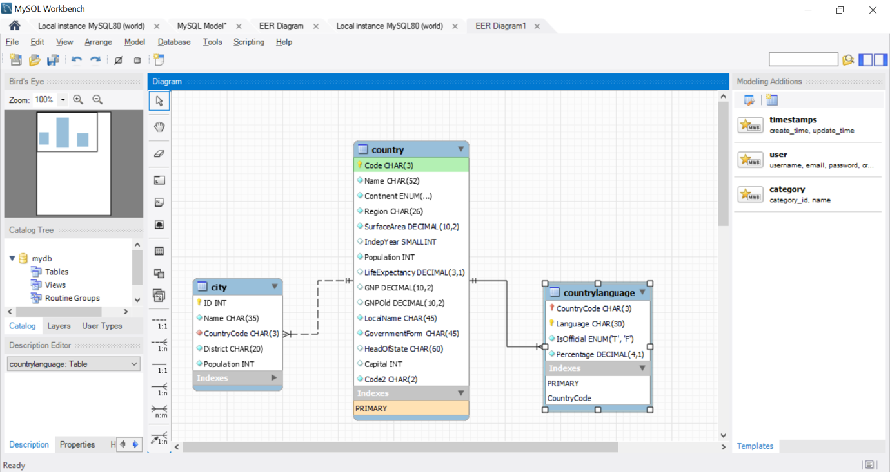

# Task19# Primary key in city table

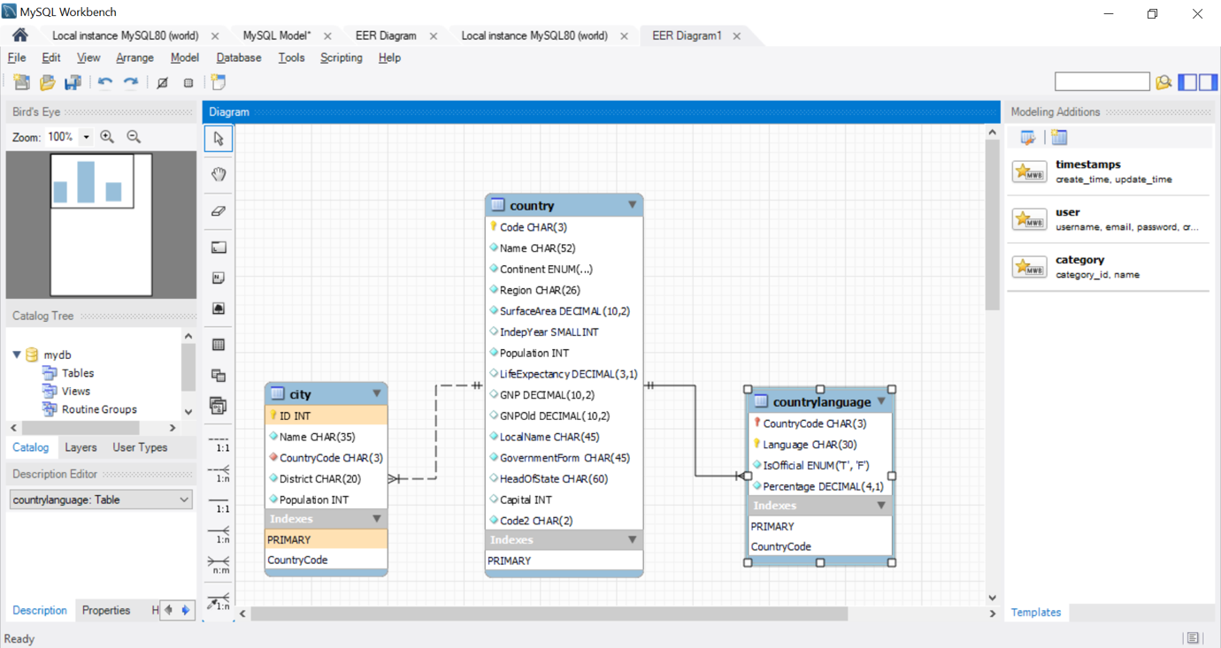

# Task20# Primary key in countrylanguage table.

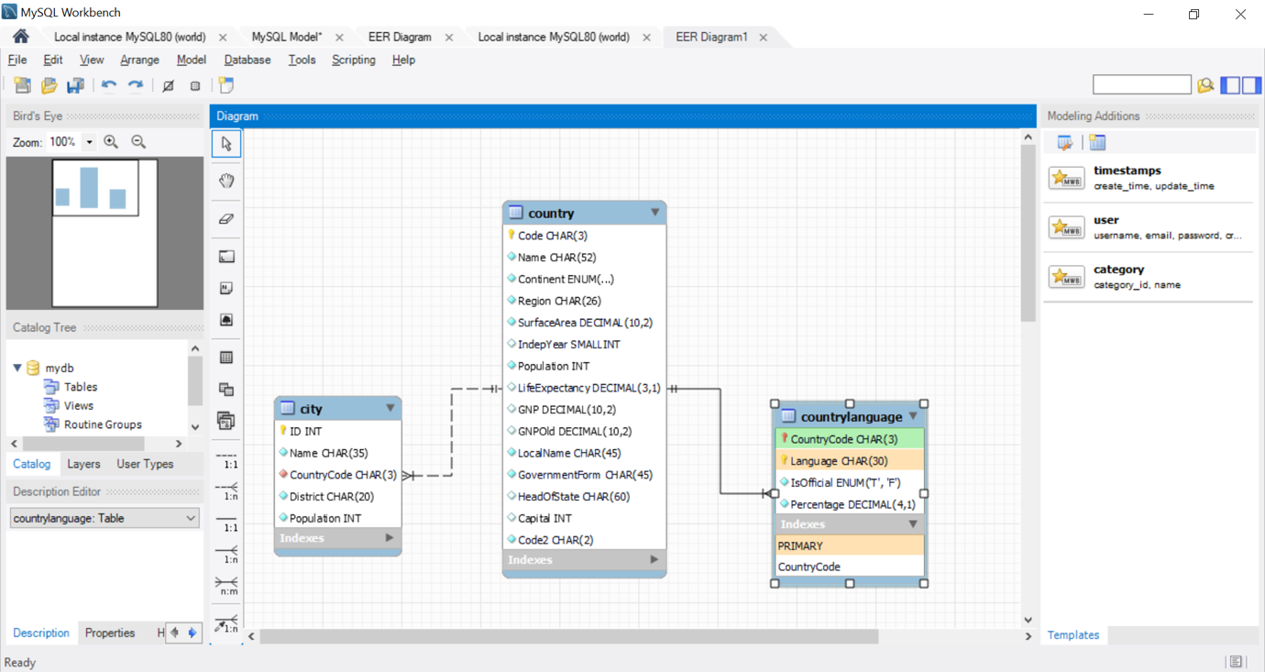

# Task21# Foreign key in city table



# 

# Task22# Foreign key in countrylanguage table



# Task23# Relation between tables.

